QUESTION : 1
Create a table called Orders with columns: order_id, user_id, order_date, and total_amount. Insert at least 7 sample rows representing different users and dates, similar to how food orders appear in Zomato or Swiggy :
TABLE Orders :
CREATE TABLE Orders(
order_id INT,
user_id INT,
order_date DATE,
total_amount DECIMAL(10,2),
PRIMARY KEY(order_id)
);
INSERT INTO Orders(order_id,user_id,order_date,total_amount)
VALUES (1,101,'2026-07-01',450.00), (2,101,'2026-07-05',620.00),
(3,101,'2026-07-10',380.00), (4,102,'2026-07-02',550.00), (5,102,'2026-07-08',700.00),
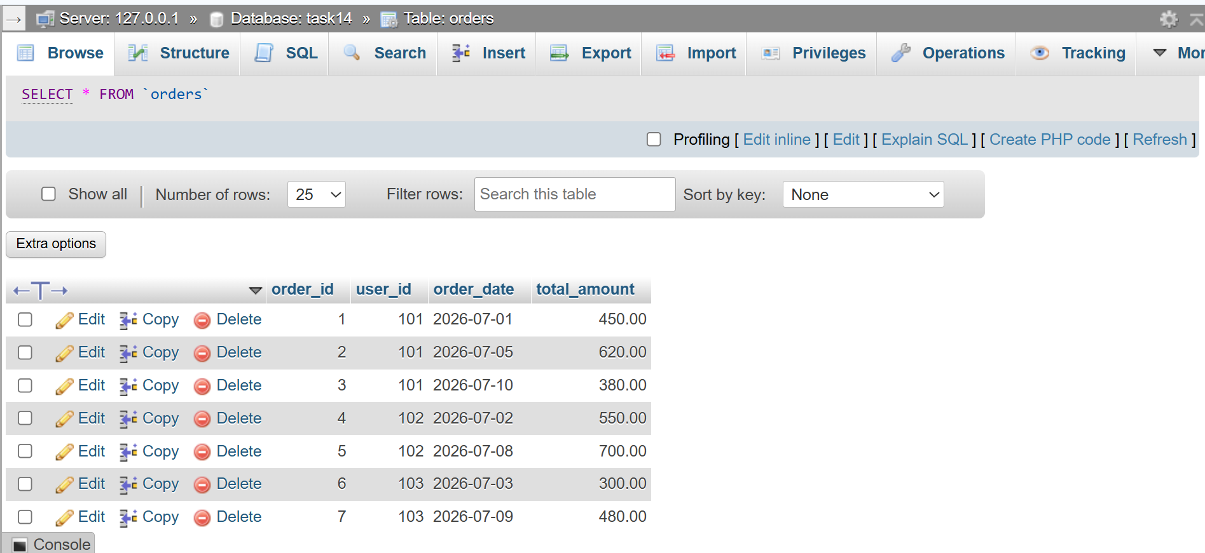
(6,103,'2026-07-03',300.00), (7,103,'2026-07-09',480.00);
QUESTION : 2
Write a SQL query using the LAG() function to show each user's order_id, order_date, and the total_amount of their previous order (if any), ordered by user and date.<br><br><em><strong>Hint:</strong> Use PARTITION BY user_id and ORDER BY order_date in your window function.</em> :

SELECT user_id,order_id,order_date,total_amount,
LAG(total_amount) OVER(PARTITION BY user_id ORDER BY order_date)
AS previous_order_amount
FROM Orders;
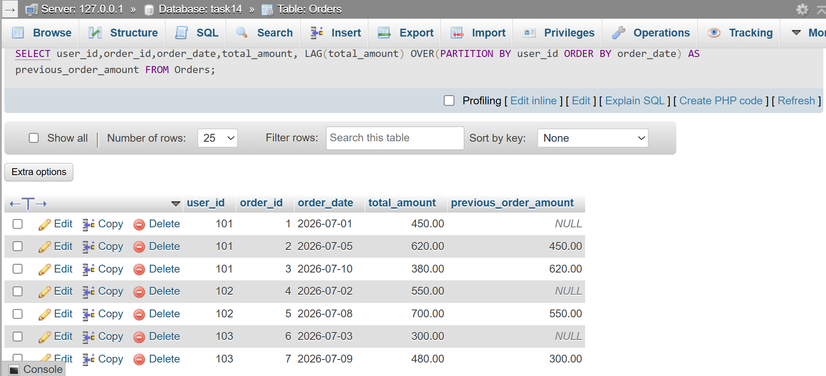

QUESTION : 3
Using the same Orders table, write a SQL query with the LEAD() function to display each order_id, order_date, and the next order's total_amount for the same user :

SELECT user_id,order_id,order_date,total_amount,
LEAD(total_amount) OVER(PARTITION BY user_id ORDER BY order_date)
AS next_order_amount
FROM Orders;
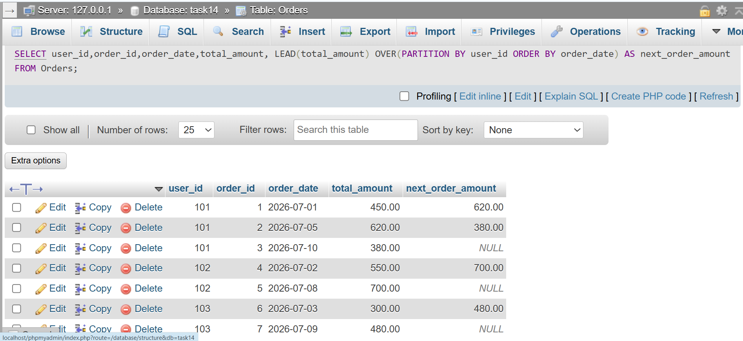

QUESTION : 4
Write a SQL query to calculate the running total of total_amount for each user, showing order_id, order_date, total_amount, and a column running_total that accumulates the sum as you move through each user's orders.<br><br><em><strong>Hint:</strong> Use SUM(total_amount) OVER (PARTITION BY user_id ORDER BY order_date ROWS BETWEEN UNBOUNDED PRECEDING AND CURRENT ROW).</em> :

SELECT user_id,order_id,order_date,total_amount,
SUM(total_amount) OVER(PARTITION BY user_id ORDER BY order_date
ROWS BETWEEN UNBOUNDED PRECEDING AND CURRENT ROW) AS running_total
FROM Orders;
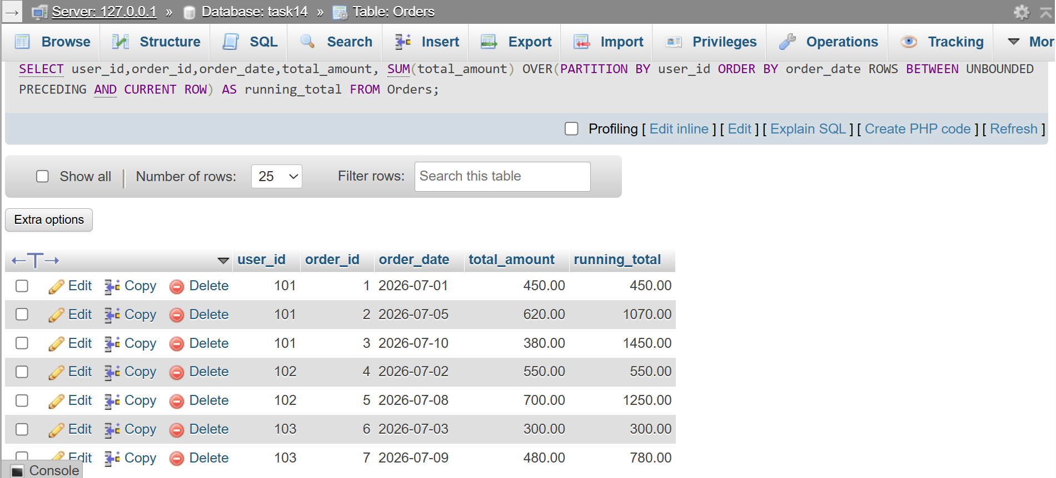

QUESTION : 5
Write a SQL query to calculate a 3-order moving average of total_amount for each user, showing order_id, order_date, total_amount, and moving_avg columns.<br><br><em><strong>Constraint:</strong> Use SUM() OVER() with ROWS BETWEEN 2 PRECEDING AND CURRENT ROW to compute the moving average.</em> :

Moving Average = Number of orders / SUM of last 3 orders​
SELECT user_id,order_id,order_date,total_amount,
SUM(total_amount) OVER(PARTITION BY user_id ORDER BY order_date
ROWS BETWEEN 2 PRECEDING AND CURRENT ROW) /
COUNT(*) OVER(PARTITION BY user_id ORDER BY order_date
ROWS BETWEEN 2 PRECEDING AND CURRENT ROW) AS moving_avg
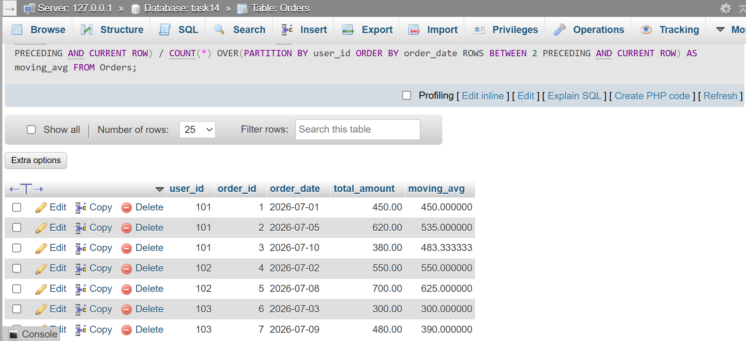
FROM Orders;

